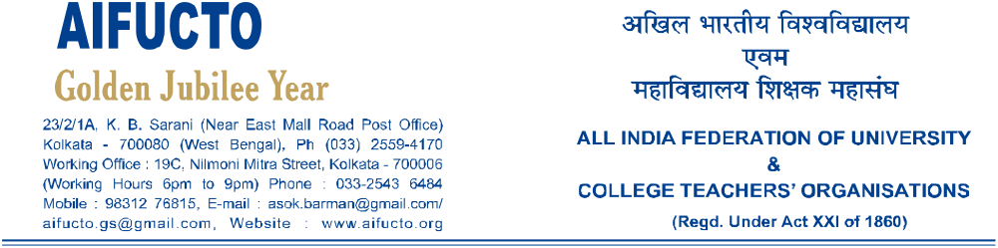CONF-13/Invitation/JNUTA 10.11.13

President, General Secretary & leaders

JNU Teachers’ Association

New Delhi
Dear Friends,
Greetings from All India Federation of University & College Teachers Organizations.
We are happy to inform you that our Federation is going to organize our next Statutory Conference at Mangalore, Karnataka, India from 30th November to 2nd December,2013.
We cordially invite you in the program. Our Conference is held in a crucial moment when our higher education is facing many problems & uncertainties we shall focus on them.
We congratulate you for your enthusiastic participation in the Delhi rally on 20th September, 2013.Let us join hands to fight for the cause of higher education & the rights of the teachers.
We do hope you would be able to make it . Your participation will encourage the participants from all over the country.
We are eagerly waiting for your participation.
Warm regards,
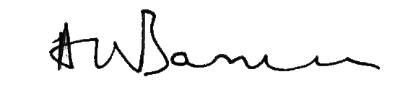
Asok Barman
General Secretary

